City of River Falls, Wisconsin | Community Opportunities Profile

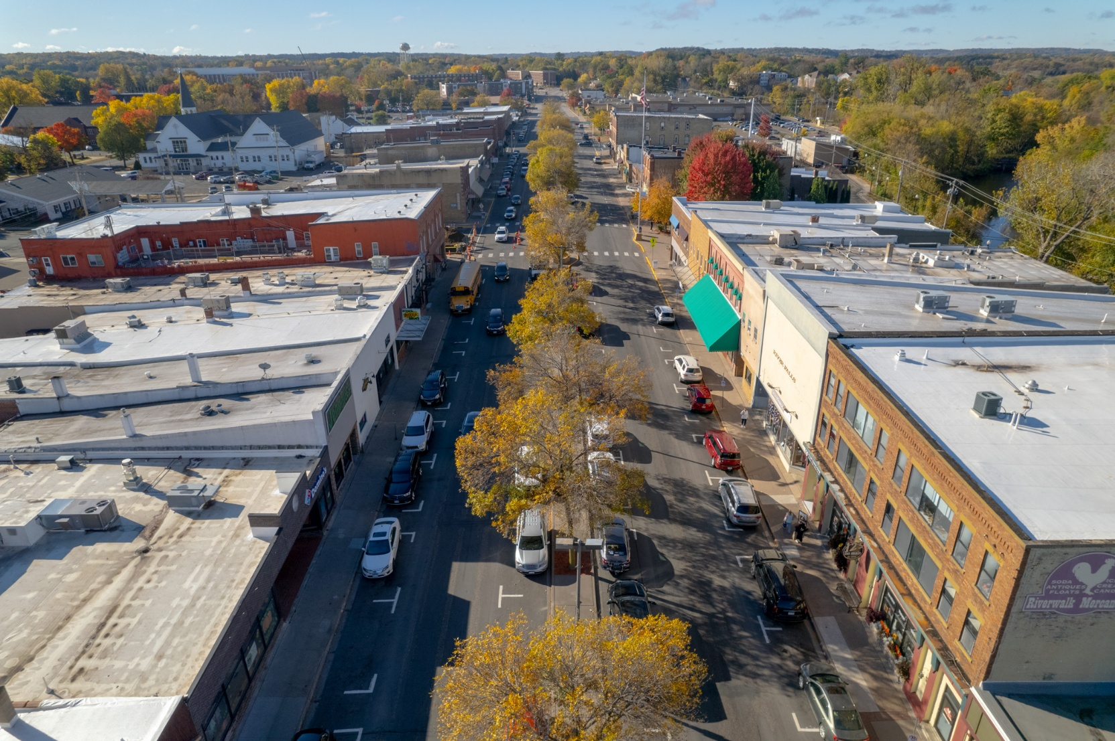

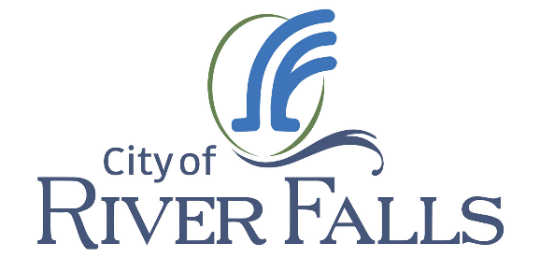
Opportunity for Project XXXXXXX
Table of Contents
Letter from the City Administrator 1
Location Information 3
River Falls Community Highlights 4
Population: 4
Active & Engaged Lifestyle: 4
Recognized for Excellence: 4
Sustainability Leader: 4
Colleges & Universities 5
Regional Access to Higher Education: 5
Local Talent, Ready to Work: 5
Regional Hiring Support: 5
University Talent Pipeline: 5
Sterling Ponds Corporate Park 6
Multi-Tenant Industrial Building 6
Sterling Ponds Corporate Park 7
St. Croix Valley Business Innovation Center 7
River Falls Municipal Utilities 8
Free Transformer for New Buildings: 8
Economic Development Electric Rate: 8
New Construction Program: 8
Loan and Tax Credit Programs Available 9
Business Development Tax Credits Business Development Tax Credit (BTC) Program 9
Revolving Loan Fund (Revolving Loan Fund) 9

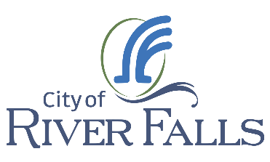
May 9, 2025

Opportunities in River Falls, Wisconsin

Mr. Koelsch,

River Falls is a full-service community uniquely positioned with close proximity to the Minnesota border and Twin Cities markets. A vibrant Main Street with a diverse mix of professional services, restaurants, and retail shops adds to the small-town charm of River Falls. A distinctive, vibrant, and safe city with an abundance of nature and easy access to metropolitan amenities, where families and businesses have what they need to flourish.

River Falls businesses maintain a highly visible location along State Highway 35 just 5 miles south of Interstate 94 and only 7 miles from the Minnesota River crossing. Residents and businesses enjoy a fast 6-minute connection to I-94 and can be in downtown Saint Paul in less than 30 minutes or MSP airport in 40.

The City is home to the University of Wisconsin – River Falls, Chippewa Valley Technical College, and dozens of businesses including many historically listed on the Inc 500 list, Minnesota corporate giants like Nash Finch and Land O Lakes, and companies flying flags of their owners from Ireland, Germany, France, and Israel. Your corporate neighbors will include innovators in plastics, food, mini markets, plant genetics, metal manufacturing, material science, 3D printing, specialty coatings, architectural wooden doors, cabinetry and casework, LED drying technology, and more.

We appreciate your time and invite you to consider investing in the community. Please feel free to contact me at (715) 426-3402 should you have any questions or elaboration.

Sincerely,
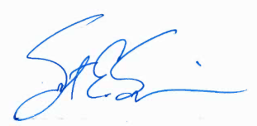
Scot E. Simpson
City Administrator

Location Information

Strategic Location. Seamless Access.

River Falls, Wisconsin is ideally positioned along Highways 35, 65 and 29 – just minutes from I-94, under 30 minutes to downtown St Paul, and 40 minutes to MSP International Airport.

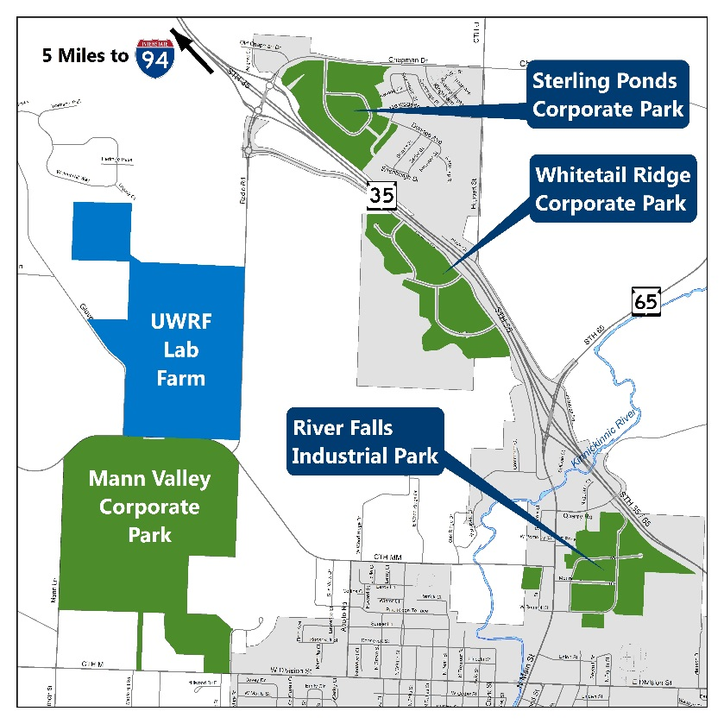
The Radio Road Interchange, completed in 2014, provides direct access to the Sterling Ponds Corporate Park. Recent improvements to Radio Road (now County Hwy U) further expand connectivity to prime development areas.
River Falls: Where business meets opportunity.

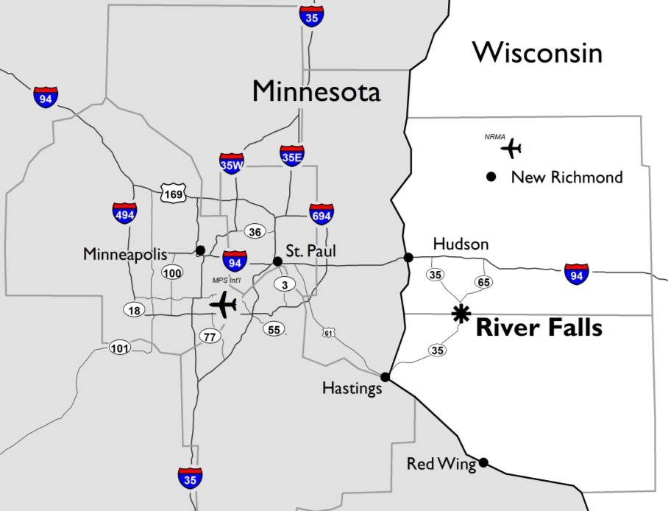
River Falls At-A-Glance
- Located in the Twin Cities Metro with the tax advantage of Wisconsin.
- Under 5 miles from I-94 via 4-lane access and the new Radio Road Interchange
- 40 minutes to Minneapolis-St. Paul International Airport
- 400+ acres of city-owned land, plus adjacent private development sites.
- Home of the University of Wisconsin-River Falls and Chippewa Valley Technical College

River Falls Community Highlights

A growing City with Small-Town Charm and Big Opportunities

Population:
Estimated at 17,445 in 2024 and growing, River Falls is part of the dynamic Twin Cities metro and one of Wisconsin’s fastest growing regions.

Active & Engaged Lifestyle:
Residents enjoy an expansive trail network, a Class I trout stream, and year-round outdoor recreation in this award-winning America in Bloom City.

Recognized for Excellence:
Designated a Bicycle Friendly Community, Playful City, Tree City, Bee City, and Bird City Wisconsin, River Falls promotes wellness, sustainability, and inclusiveness.

Sustainability Leader:
Home to Wisconsin’s first LEED-certified City Hall and a top 5 nationally ranked municipal utility for green power sales.



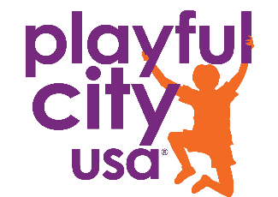
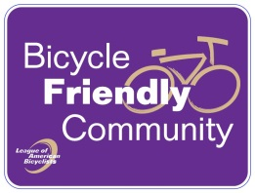

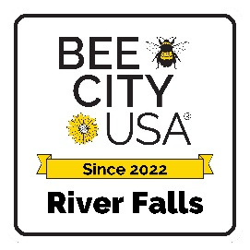


Colleges & Universities
River Falls is a hub for higher education, anchored by two local institutions:

- University of Wisconsin-River Falls (UW-River Falls)

A long-standing part of the community since 1874, this NCAA Division III university spans 226 acres in the heart of the city. A new $110 million Science and Technology Innovation Center (SciTech) is underway to support STEM education and industry collaboration.

- Chippewa Valley Technical College (CVTC)

Serving an 11-county region, CVTC recently expanded its River Falls campus to meet growing demand for mechanical and technology programs.

Regional Access to Higher Education:
With its proximity to the Twin Cities, River Falls offers easy access to numerous public and private colleges in both Wisconsin and Minnesota, including UW-Stout (40 min), UW-Eau Claire (1 hour), and Northwood Technical College in New Richmond (20 min).

Local Talent, Ready to Work:
About 75% of River Falls residents commute to jobs in other communities – representing a strong pool of potential employees for business locating in the city.

(Information compiled from the recent River Falls Housing Needs Analysis, and the updated 2022 Housing Study.)

Regional Hiring Support:
The St. Croix Valley Job Center, St. Croix’s Economic Development Corporation, Pierce County Economic Development Corporation, and the River Falls Chamber of Commerce provide job posting support and workforce connections.

University Talent Pipeline:
UW-River Falls offers access to skilled students for part-time, seasonal, and internship positions. Faculty and staff relocating to the area often bring additional talent to the local job market.

Sterling Ponds Corporate Park

Multi-Tenant Industrial Building

Located in River Falls’ high-growth northern corridor, Sterling Ponds Corporate Park offers a prime location for industrial and commercial development.

The park features the 108,000 sq. ft. Sterling Ponds Industrial I multi-tenant building, with plans underway for Sterling Ponds Industrial II on the adjacent Lot J. 54,000 sq/ft of flexible warehouse and industrial space is still available in the multi-tenant building.

Zoned I-1 Industrial, the park is guided by modern development covenants and design standards to ensure quality and consistency. Explore the opportunity and watch the video of the Sterling Ponds Corporate Park here.

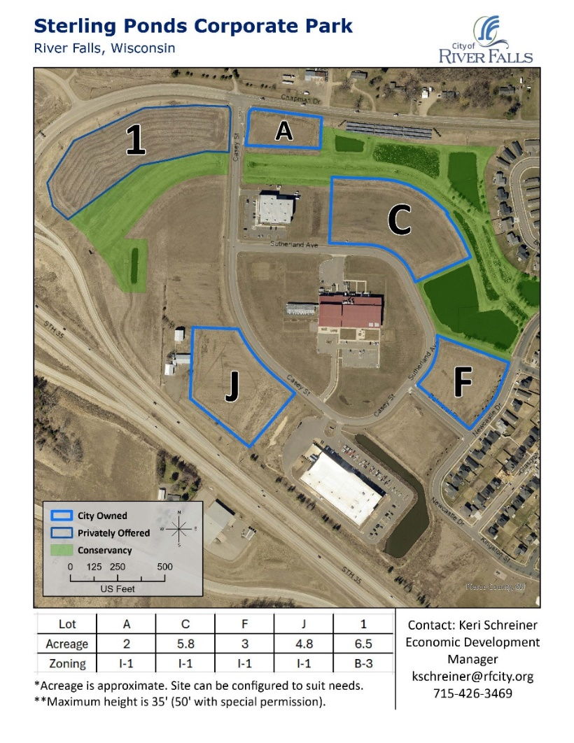

Sterling Ponds Corporate Park

St. Croix Valley Business Innovation Center

The St. Croix Valley Business Innovation Center (SCVBIC) opened in 2018 and serves business growth and development in the St. Croix Valley. The facility offers private offices, light manufacturing, and co-working space in addition to business advisers and coaches for entrepreneurs and business owners. SCVBIC is a collaborate partnership among the University of Wisconsin – River Falls, City of River Falls, Chippewa Valley Technical College, and the River Falls Economic Development Corporation.

In conjunction with UWRF’s Center for Innovation and Business Development, the SCVBIC offers services to persons in the exploratory stages of forming a business, start-up businesses or State 1 businesses, existing Stage 2 businesses, and larger more established businesses. Services include affordable rental space, business planning, coaching and mentoring assistance, business software, financial advisory service, market development assistance, export assistance, networking opportunities, and access to UWRF resources. Sheri Marnell is the of the Innovation Center.

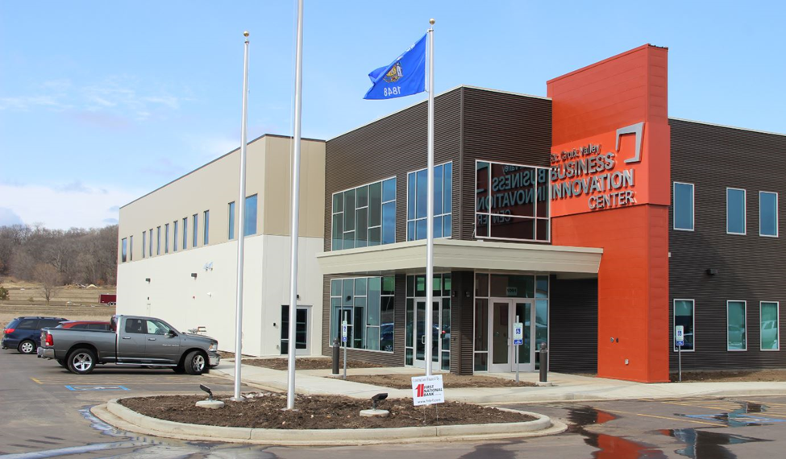

River Falls Municipal Utilities

Reliable. Responsive. Forward-Thinking.

River Falls Municipal Utilities (RFMU) is a locally-owned utility delivering reliable, cost-effective energy with personalized service. Businesses benefit from direct access to energy experts who offer tailored solutions and efficiency-focused programs.

- Business-Friendly Energy Programs:
RFMU’s New Construction Economic Development Program helps businesses design high-performance buildings that reduce energy use, lower costs, and improve comfort.
- Green Energy Leadership:
RFMU ranks #1 in Wisconsin and #5 nationally in green power sales. Businesses can purchase green energy blocks or participate in the Community Solar Program to receive energy credits and support sustainability goals.
- Reliable, Local Service:
With in-house utility testing and a newly upgraded substation serving the northern corporate parks, RFMU ensures dependable service for critical business operations;

Explore how RFMU can power your business at rfmu.org

Free Transformer for New Buildings:

River Falls Municipal Utilities (RFMU) provides a new transformer for your building expansion at no-cost saving up to $100,000.

Economic Development Electric Rate:

For new or expanding businesses with a load level of 400 kW, RFMU offers an Economic Development Rate that’s 1-1.5 cents cheaper per kWh than the standard industrial rate for the first four years.

New Construction Program:
Since 2015, RFMU has offered businesses energy efficiency grants for new construction. These grants help cover the costs of upgrades like energy-efficient HVAC systems, lighting, and premium motors. For more information on the New Construction Economic Development Program, contact the City’s WPPI Energy Service Manager at jwilli@wppienergy.org.

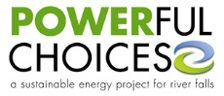

Loan and Tax Credit Programs Available

Incentives to Grow Your Business

Business Development Tax Credits Business Development Tax Credit (BTC) Program
Wisconsin offers refundable tax credits to support job creation, capital investment, employee training, and corporate headquarters projects. These credits can reduce your state income tax liability or provide a cash refund.

Revolving Loan Fund (Revolving Loan Fund)
Through the Regional Business Fund, Inc., businesses can access flexible, low-interest loans for working capital, equipment, or real estate. This fund helps bridge financing gaps for projects that benefit the local economy.

